Email Spam Classifier
Author: SUSMITHA P

EXECUTIVE SUMMARY:

The SmartMail AI is an intelligent email security system developed to automatically analyze email content and detect malicious messages such as spam, scams, and phishing attempts, helping reduce the risks of fraud, misinformation, and identity theft.

The system integrates machine learning techniques with cybersecurity-based threat analysis, enabling it to not only classify emails accurately but also evaluate behavioral indicators such as suspicious links, urgency patterns, and financial cues.

It provides detailed and explainable outputs including confidence scores, threat severity levels, and highlighted suspicious patterns, allowing users to clearly understand why an email is flagged and take appropriate action.

PROJECT OVERVIEW:

Objective:

The objective of this project is to build an intelligent email security system to detect spam, phishing, and malicious emails using machine learning and threat analysis. It also aims to provide clear, explainable, and confidence-based results to support user understanding.

Scope:

Email text preprocessing and normalization

Word-level and character-level TF-IDF feature extraction

Ensemble model training and validation

Threat risk scoring and severity classification

Multi-category email classification (Safe, Promotion, Spam, Scam, Phishing)

Real-time email scanning and analysis

Key Features:

- Ensemble Classification:
Uses a combination of Naive Bayes and Logistic Regression models to improve detection accuracy and robustness.
- Dual Feature Extraction:
Applies both word-level and character-level n-grams to capture semantic meaning and obfuscated spam patterns.
- Phishing Detection Engine:
Analyzes suspicious keywords and links to identify phishing attempts and credential-harvesting emails.
- Threat Scoring System:
Generates a numerical risk score on a 0–10 scale to represent the potential danger of each email.
- Severity Level Classification:
Assigns severity labels such as Low, Medium, High, and Critical to prioritize threats..
- Confidence Fusion Mechanism:
Combines machine learning probabilities with rule-based threat indicators to produce final confidence values.
- Real-Time Email Analysis:
Supports multi-line email input and processes messages instantly.

TECHNICAL IMPLEMENTATION:

Technology Stack:
- Programming Language: Python
- Data Processing: Pandas, NumPy
- NLP Tools: NLTK
- Machine Learning: Scikit-learn
- Feature Engineering: TF-IDF (word + character n-grams)
- Database: MongoDB or PostgreSQL
- Visualization Tools: Matplotlib, Seaborn
- Deployment Environment: Virtual Environment

Performance Metrics:
• Accuracy, precision, recall, and F1-score measure performance.
• Cross-validation evaluates model stability.
• Confusion matrices visualize prediction behavior.
• Threat scores and confidence values assess security risk.

SOURCE CODE IMPLEMENTATION :

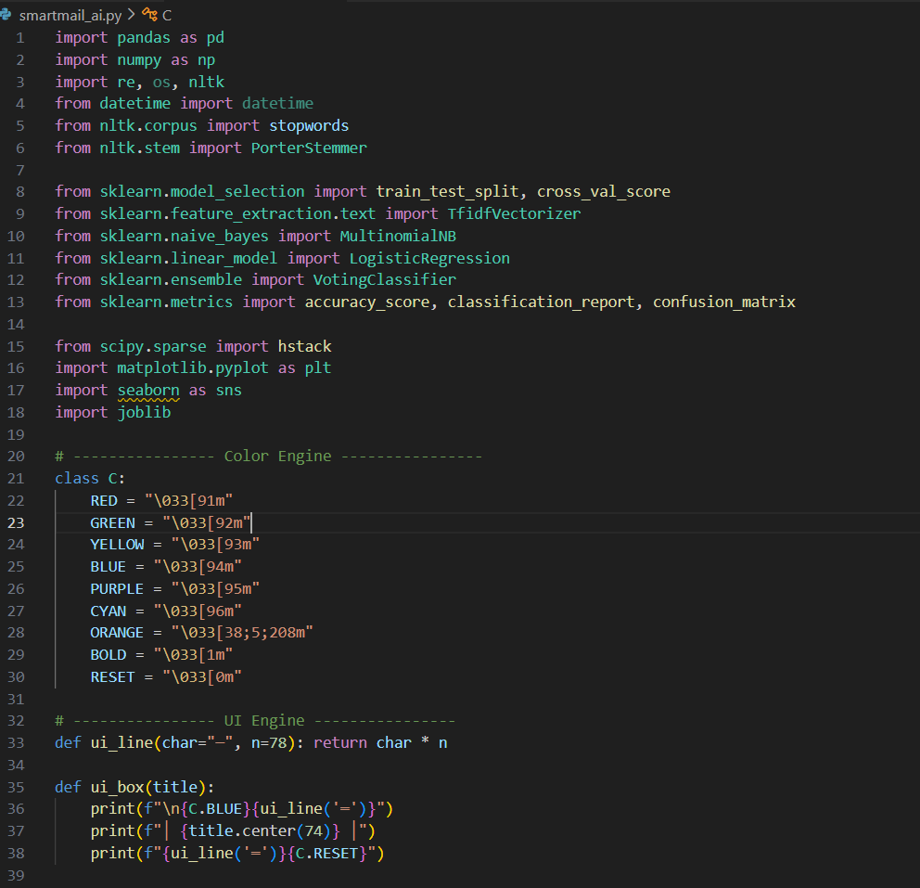
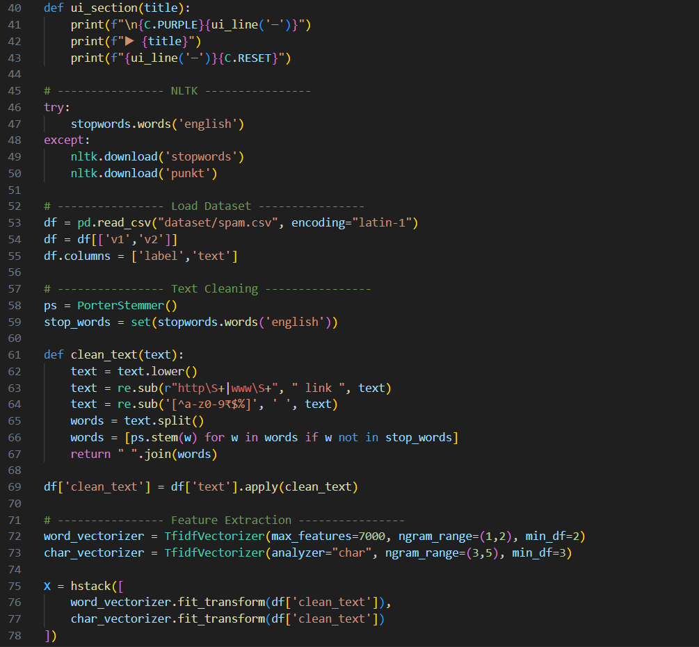
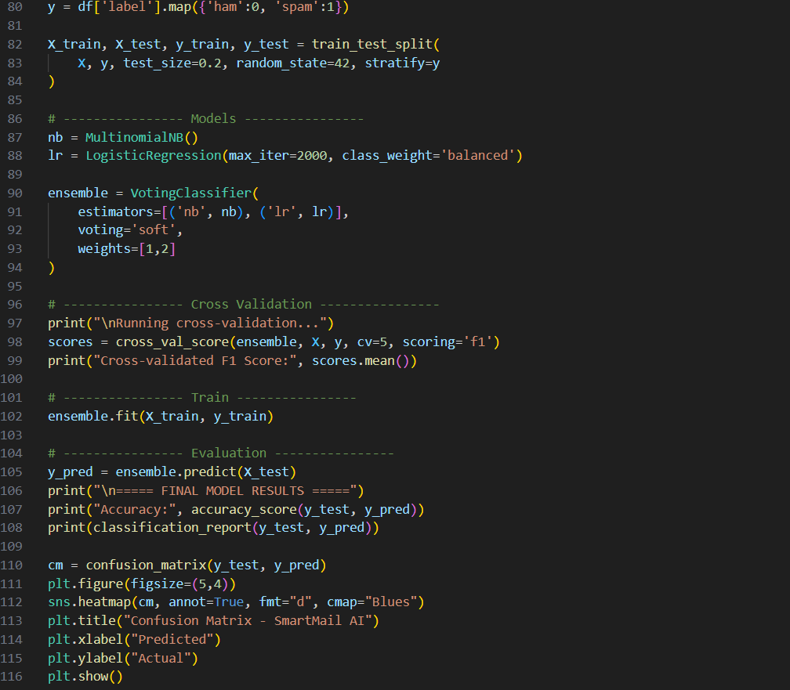

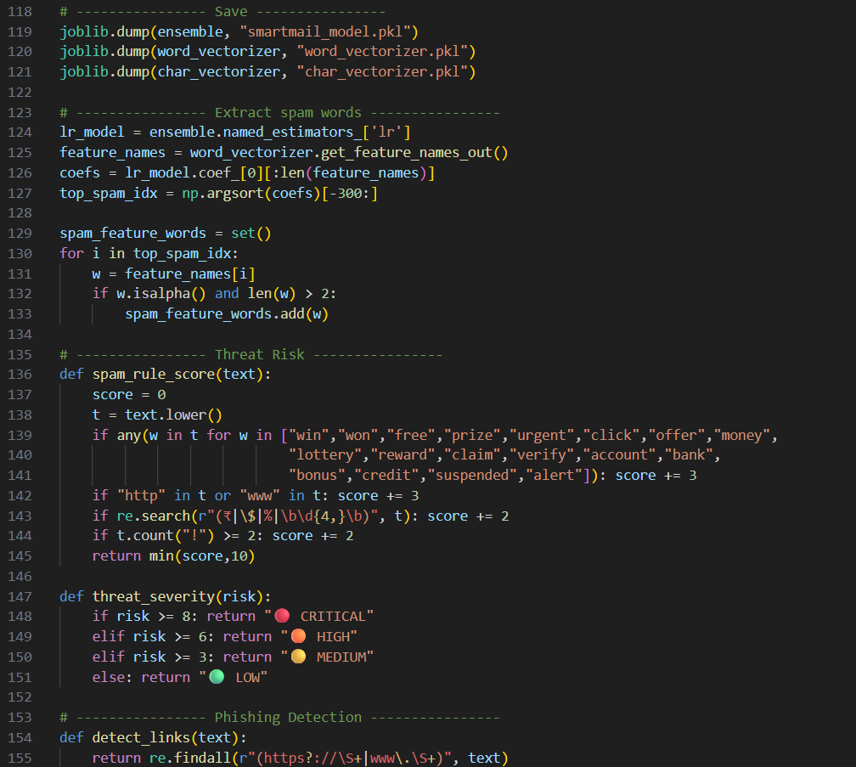

Dataset:


System Performance Results:
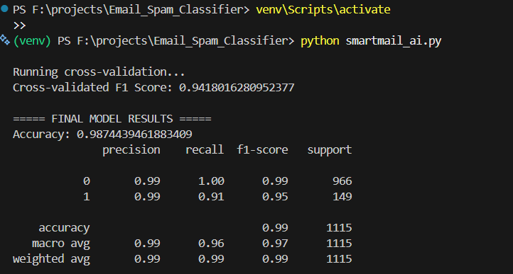

Safe Mail:
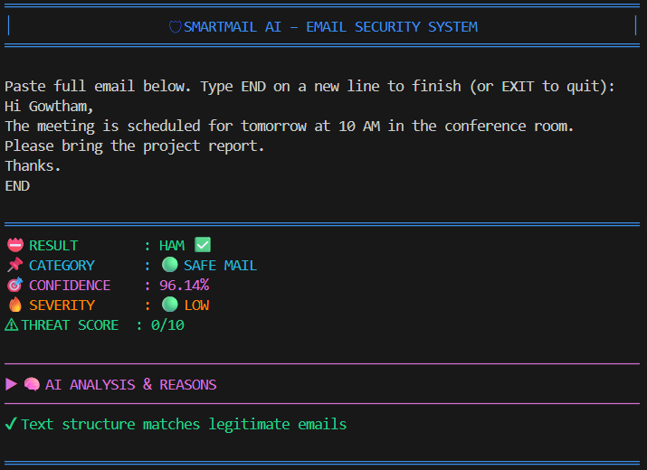

PHISHING:
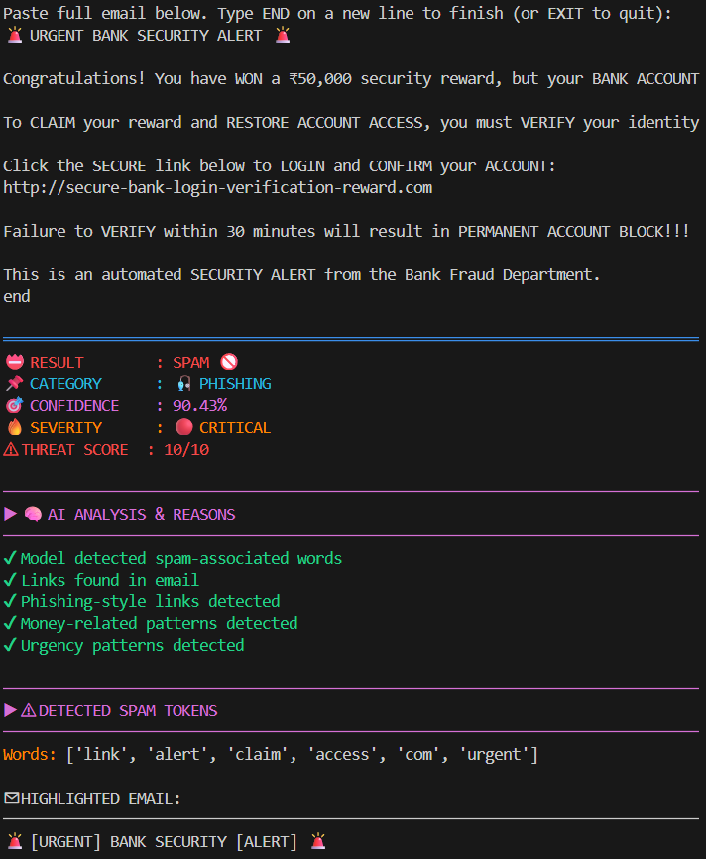
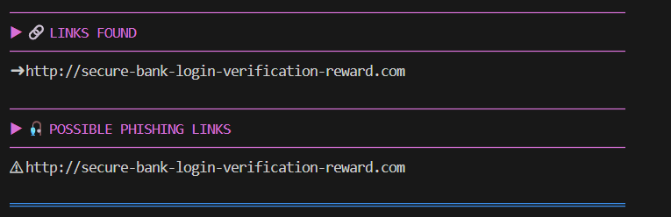

SPAM:
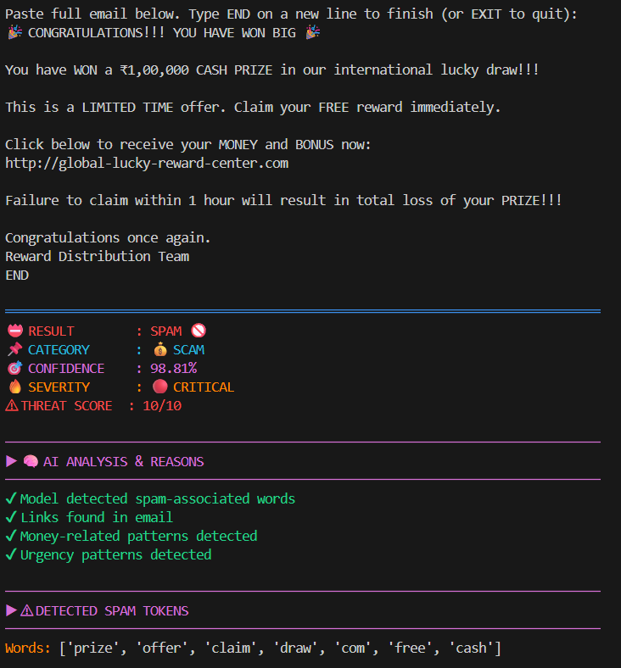
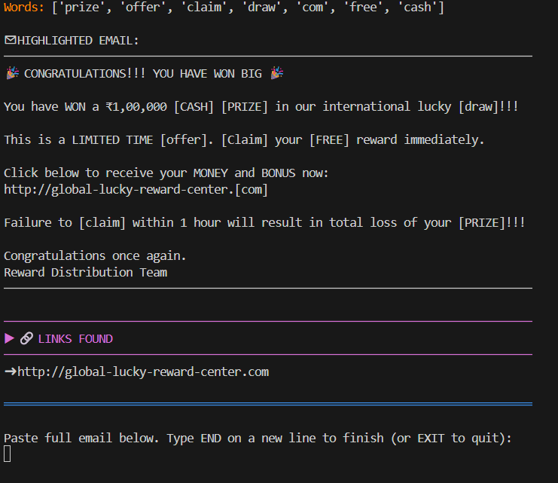

Email Logs (csv):
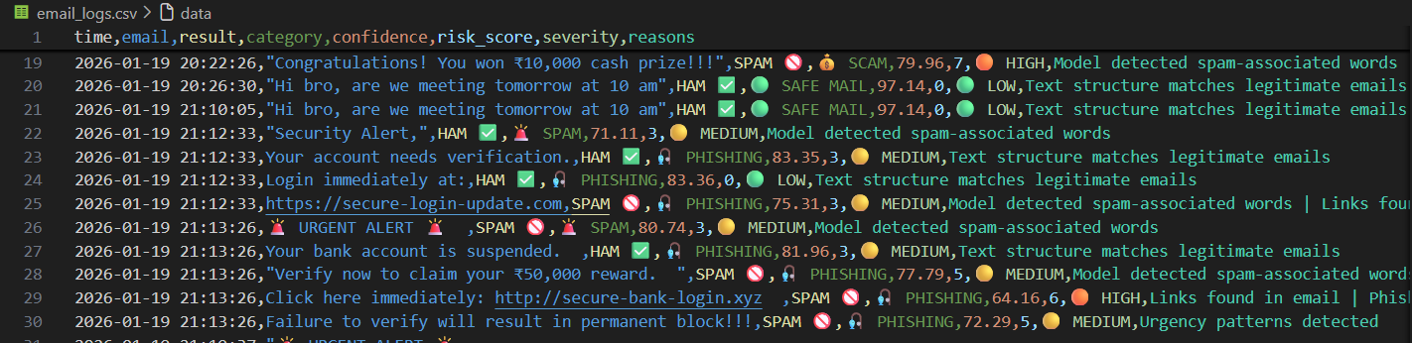

KEY ACHIEVEMENTS:
Technical Accomplishments:

- Developed an ensemble machine learning–based email security system.
- Implemented phishing detection and behavioral threat analysis.
- Designed a threat scoring and severity classification framework.
- Integrated explainable AI features for transparent detection.
- Enabled real-time email analysis with visual performance evaluation.

mk

CONSTRAINTS:

Resource Constraints:
• The system depends on public datasets.
• Only email text is currently analyzed.
• Real-world phishing samples are limited.
• Computational resources restrict scalability.
• Real-time server integration is not implemented.

PROJECT IMPACT AND VALUE:

Immediate Benefits :

• Provides automated detection of spam, scam, and phishing emails.
• Reduces user exposure to malicious and fraudulent messages.
• Improves awareness through explainable threat analysis.
• Supports real-time email security monitoring.
• Enhances digital safety and trust in email communication.

Long-Term Potential :

• Can be expanded into enterprise-level email security solutions.
• Supports integration with cloud-based and large-scale systems.
• Enables future use of advanced deep learning and threat intelligence.
• Can be extended to protect other digital communication platforms.
• Offers a foundation for continuous learning and adaptive security systems.

CONCLUSION:
SmartMail AI successfully demonstrates the effective integration of machine learning techniques with cybersecurity-based threat analysis to detect spam, scam, and phishing emails, showing that hybrid intelligent systems can significantly improve the accuracy, reliability, and adaptability of modern email security solutions.
The system not only provides real-time threat detection, but also delivers explainable and confidence-driven results with severity assessment, making it a strong foundation for future expansion into enterprise-level platforms and real-world digital communication security systems.

